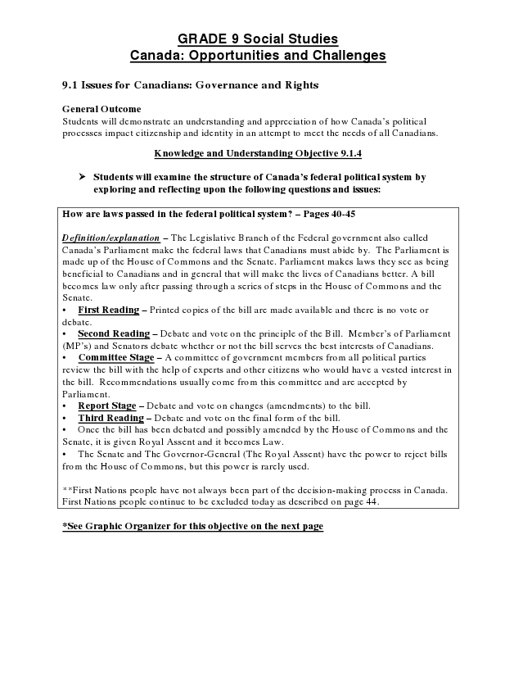
GRADE 9 Social Studies Canada: Opportunities and Challenges
9.1 Issues for Canadians: Governance and Rights
General Outcome Students will demonstrate an understanding and appreciation of how Canada’s political processes impact citizenship and identity in an attempt to meet the needs of all Canadians.
Knowledge and Understanding Objective 9.1.4
➢ Students will examine the structure of Canada’s federal political system by
exploring and reflecting upon the following questions and issues:
How are laws passed in the federal political system? – Pages 40-45
Definition/explanation – The Legislative Branch of the Federal government also called Canada’s Parliament make the federal laws that Canadians must abide by. The Parliament is made up of the House of Commons and the Senate. Parliament makes laws they see as being beneficial to Canadians and in general that will make the lives of Canadians better. A bill becomes law only after passing through a series of steps in the House of Commons and the Senate.
• First Reading – Printed copies of the bill are made available and there is no vote or debate.
• Second Reading – Debate and vote on the principle of the Bill. Member’s of Parliament (MP’s) and Senators debate whether or not the bill serves the best interests of Canadians.
• Committee Stage – A committee of government members from all political parties review the bill with the help of experts and other citizens who would have a vested interest in the bill. Recommendations usually come from this committee and are accepted by Parliament.
• Report Stage – Debate and vote on changes (amendments) to the bill.
• Third Reading – Debate and vote on the final form of the bill.
• Once the bill has been debated and possibly amended by the House of Commons and the Senate, it is given Royal Assent and it becomes Law.
• The Senate and The Governor-General (The Royal Assent) have the power to reject bills from the House of Commons, but this power is rarely used.
**First Nations people have not always been part of the decision-making process in Canada. First Nations people continue to be excluded today as described on page 44.
*See Graphic Organizer for this objective on the next page

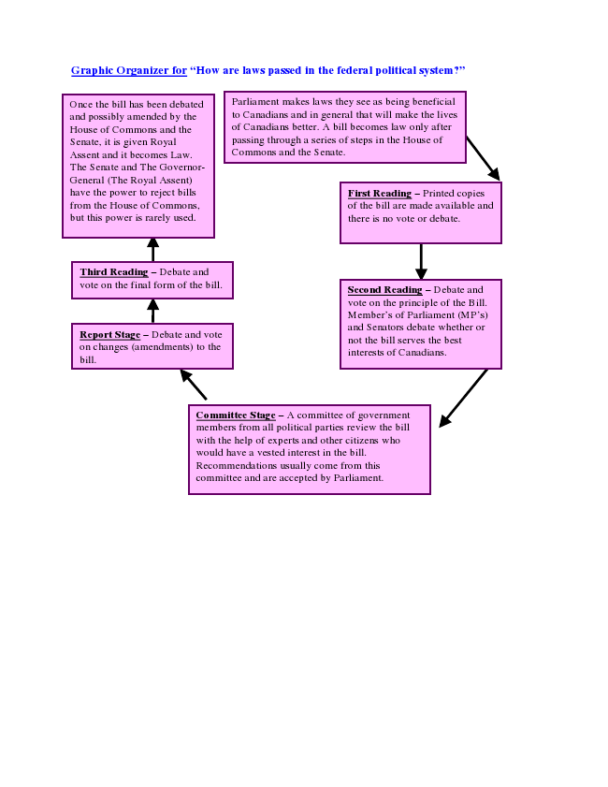
Graphic Organizer for “How are laws passed in the federal political system?”
Once the bill has been debated Parliament and possibly amended by the House of Commons and the Senate, it is given Royal Assent and it becomes Law.
Third Reading – Debate and vote on the final form of the bill.
Report Stage – Debate and vote on changes (amendments) to the bill.
makes laws they see as being beneficial to Canadians and in general that will make the lives of Canadians better. A bill becomes law only after passing through a series of steps in the House of Commons and the Senate. The Senate and The Governor- General (The Royal Assent) have the power to reject bills
First Reading – Printed copies from the House of Commons,
of the bill are made available and but this power is rarely used.
there is no vote or debate.
Second Reading – Debate and vote on the principle of the Bill. Member’s of Parliament (MP’s) and Senators debate whether or not the bill serves the best interests of Canadians.
Committee Stage – A committee of government members from all political parties review the bill with the help of experts and other citizens who would have a vested interest in the bill. Recommendations usually come from this committee and are accepted by Parliament.

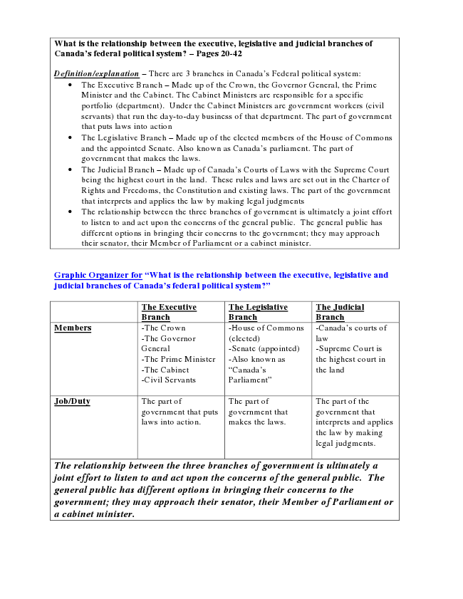
What is the relationship between the executive, legislative and judicial branches of Canada’s federal political system? – Pages 20-42
Definition/explanation – There are 3 branches in Canada’s Federal political system:
• The Executive Branch – Made up of the Crown, the Governor General, the Prime Minister and the Cabinet. The Cabinet Ministers are responsible for a specific portfolio (department). Under the Cabinet Ministers are government workers (civil servants) that run the day-to-day business of that department. The part of government that puts laws into action
• The Legislative Branch – Made up of the elected members of the House of Commons and the appointed Senate. Also known as Canada’s parliament. The part of government that makes the laws.
• The Judicial Branch – Made up of Canada’s Courts of Laws with the Supreme Court being the highest court in the land. These rules and laws are set out in the Charter of Rights and Freedoms, the Constitution and existing laws. The part of the government that interprets and applies the law by making legal judgments
• The relationship between the three branches of government is ultimately a joint effort to listen to and act upon the concerns of the general public. The general public has different options in bringing their concerns to the government; they may approach their senator, their Member of Parliament or a cabinet minister.
Graphic Organizer for “What is the relationship between the executive, legislative and judicial branches of Canada’s federal political system?”
The Executive Branch
The Legislative Branch
The Judicial Branch Members -The Crown
-The Governor General -The Prime Minister -The Cabinet -Civil Servants
-House of Commons (elected) -Senate (appointed) -Also known as “Canada’s Parliament”
-Canada’s courts of law -Supreme Court is the highest court in the land
Job/Duty The part of
government that puts laws into action.
The part of government that makes the laws.
The part of the government that interprets and applies the law by making legal judgments.
The relationship between the three branches of government is ultimately a joint effort to listen to and act upon the concerns of the general public. The general public has different options in bringing their concerns to the government; they may approach their senator, their Member of Parliament or a cabinet minister.

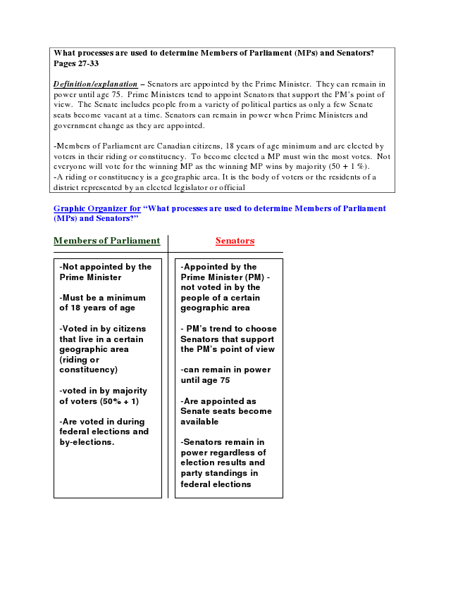
What processes are used to determine Members of Parliament (MPs) and Senators? Pages 27-33
Definition/explanation – Senators are appointed by the Prime Minister. They can remain in power until age 75. Prime Ministers tend to appoint Senators that support the PM’s point of view. The Senate includes people from a variety of political parties as only a few Senate seats become vacant at a time. Senators can remain in power when Prime Ministers and government change as they are appointed.
-Members of Parliament are Canadian citizens, 18 years of age minimum and are elected by voters in their riding or constituency. To become elected a MP must win the most votes. Not everyone will vote for the winning MP as the winning MP wins by majority (50 + 1 %). -A riding or constituency is a geographic area. It is the body of voters or the residents of a district represented by an elected legislator or official
Graphic Organizer for “What processes are used to determine Members of Parliament (MPs) and Senators?”
Members of Parliament Senators
-Not appointed by the Prime Minister
-Must be a minimum of 18 years of age
-Voted in by citizens that live in a certain geographic area (riding or constituency)
-voted in by majority of voters (50% + 1)
-Are voted in during federal elections and by-elections.
-Appointed by the Prime Minister (PM) - not voted in by the people of a certain geographic area
- PM’s trend to choose Senators that support the PM’s point of view
-can remain in power until age 75
-Are appointed as Senate seats become available
-Senators remain in power regardless of election results and party standings in federal elections

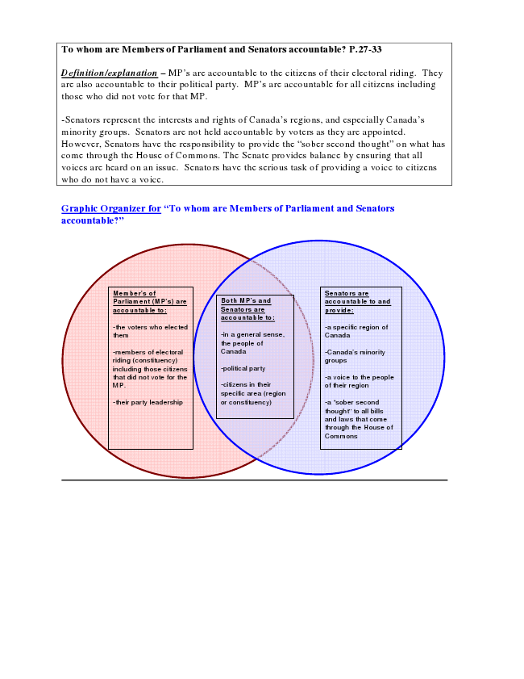
To whom are Members of Parliament and Senators accountable? P.27-33
Definition/explanation – MP’s are accountable to the citizens of their electoral riding. They are also accountable to their political party. MP’s are accountable for all citizens including those who did not vote for that MP.
-Senators represent the interests and rights of Canada’s regions, and especially Canada’s minority groups. Senators are not held accountable by voters as they are appointed. However, Senators have the responsibility to provide the “sober second thought” on what has come through the House of Commons. The Senate provides balance by ensuring that all voices are heard on an issue. Senators have the serious task of providing a voice to citizens who do not have a voice.
Graphic Organizer for “To whom are Members of Parliament and Senators accountable?”
Member’s of Parliament (MP’s) are accountable to:
-the voters who elected them
-members of electoral riding (constituency) including those citizens that did not vote for the MP.
-their party leadership
Both MP’s and Senators are accountable to:
-in a general sense, the people of Canada
-political party
-citizens in their specific area (region or constituency)
Senators are accountable to and provide:
-a specific region of Canada
-Canada’s minority groups
-a voice to the people of their region
-a “sober second thought” to all bills and laws that come through the House of Commons

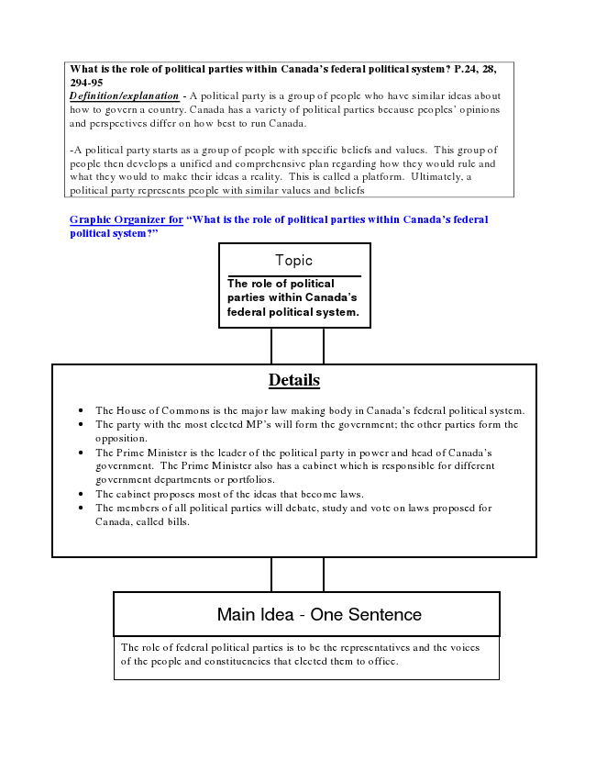
What is the role of political parties within Canada’s federal political system? P.24, 28, 294-95 Definition/explanation - A political party is a group of people who have similar ideas about how to govern a country. Canada has a variety of political parties because peoples’ opinions and perspectives differ on how best to run Canada.
-A political party starts as a group of people with specific beliefs and values. This group of people then develops a unified and comprehensive plan regarding how they would rule and what they would to make their ideas a reality. This is called a platform. Ultimately, a political party represents people with similar values and beliefs
Graphic Organizer for “What is the role of political parties within Canada’s federal political system?”
Topic
The role of political parties within Canada’s federal political system.
Details
• The House of Commons is the major law making body in Canada’s federal political system.
• The party with the most elected MP’s will form the government; the other parties form the opposition.
• The Prime Minister is the leader of the political party in power and head of Canada’s government. The Prime Minister also has a cabinet which is responsible for different government departments or portfolios.
• The cabinet proposes most of the ideas that become laws.
• The members of all political parties will debate, study and vote on laws proposed for Canada, called bills.
Main Idea - One Sentence
The role of federal political parties is to be the representatives and the voices of the people and constituencies that elected them to office.

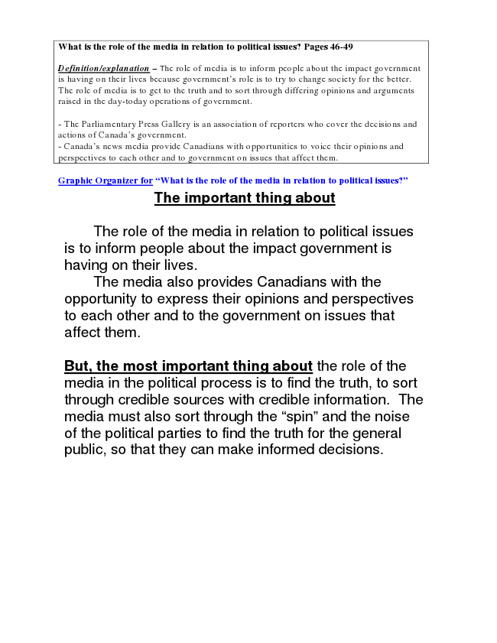
What is the role of the media in relation to political issues? Pages 46-49
Definition/explanation – The role of media is to inform people about the impact government is having on their lives because government’s role is to try to change society for the better. The role of media is to get to the truth and to sort through differing opinions and arguments raised in the day-today operations of government.
- The Parliamentary Press Gallery is an association of reporters who cover the decisions and actions of Canada’s government. - Canada’s news media provide Canadians with opportunities to voice their opinions and perspectives to each other and to government on issues that affect them.
Graphic Organizer for “What is the role of the media in relation to political issues?”
The important thing about
The role of the media in relation to political issues is to inform people about the impact government is having on their lives.
The media also provides Canadians with the opportunity to express their opinions and perspectives to each other and to the government on issues that affect them.
But, the most important thing about the role of the media in the political process is to find the truth, to sort through credible sources with credible information. The media must also sort through the “spin” and the noise of the political parties to find the truth for the general public, so that they can make informed decisions.

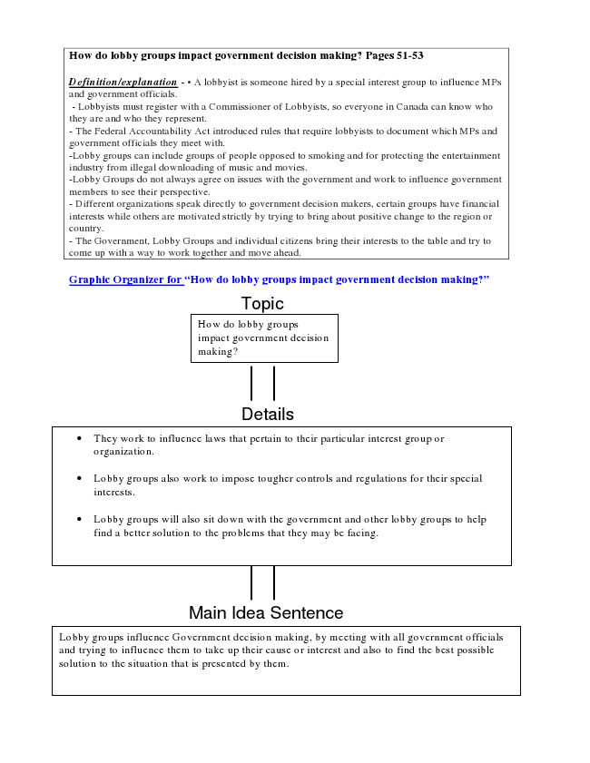
How do lobby groups impact government decision making? Pages 51-53
Definition/explanation - • A lobbyist is someone hired by a special interest group to influence MPs and government officials.
- Lobbyists must register with a Commissioner of Lobbyists, so everyone in Canada can know who they are and who they represent. - The Federal Accountability Act introduced rules that require lobbyists to document which MPs and government officials they meet with. -Lobby groups can include groups of people opposed to smoking and for protecting the entertainment industry from illegal downloading of music and movies. -Lobby Groups do not always agree on issues with the government and work to influence government members to see their perspective. - Different organizations speak directly to government decision makers, certain groups have financial interests while others are motivated strictly by trying to bring about positive change to the region or country. - The Government, Lobby Groups and individual citizens bring their interests to the table and try to come up with a way to work together and move ahead.
Graphic Organizer for “How do lobby groups impact government decision making?”
Topic How do lobby groups impact government decision making?
Details
• They work to influence laws that pertain to their particular interest group or organization.
• Lobby groups also work to impose tougher controls and regulations for their special interests.
• Lobby groups will also sit down with the government and other lobby groups to help find a better solution to the problems that they may be facing.
Main Idea Sentence
Lobby groups influence Government decision making, by meeting with all government officials and trying to influence them to take up their cause or interest and also to find the best possible solution To what to the extent situation do political that is presented and legislative by them.
processes meet the needs of all Canadians? Pages 12-52 – summary point of the entire chapter

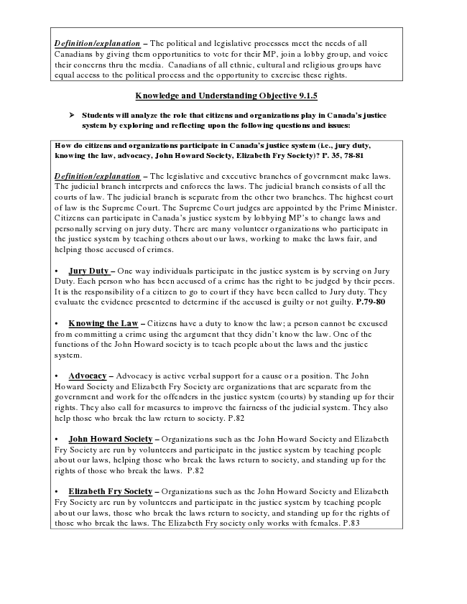
Definition/explanation – The political and legislative processes meet the needs of all Canadians by giving them opportunities to vote for their MP, join a lobby group, and voice their concerns thru the media. Canadians of all ethnic, cultural and religious groups have equal access to the political process and the opportunity to exercise these rights.
Knowledge and Understanding Objective 9.1.5
➢ Students will analyze the role that citizens and organizations play in Canada’s justice
system by exploring and reflecting upon the following questions and issues:
How do citizens and organizations participate in Canada’s justice system (i.e., jury duty, knowing the law, advocacy, John Howard Society, Elizabeth Fry Society)? P. 35, 78-81
Definition/explanation – The legislative and executive branches of government make laws. The judicial branch interprets and enforces the laws. The judicial branch consists of all the courts of law. The judicial branch is separate from the other two branches. The highest court of law is the Supreme Court. The Supreme Court judges are appointed by the Prime Minister. Citizens can participate in Canada’s justice system by lobbying MP’s to change laws and personally serving on jury duty. There are many volunteer organizations who participate in the justice system by teaching others about our laws, working to make the laws fair, and helping those accused of crimes.
• Jury Duty – One way individuals participate in the justice system is by serving on Jury Duty. Each person who has been accused of a crime has the right to be judged by their peers. It is the responsibility of a citizen to go to court if they have been called to Jury duty. They evaluate the evidence presented to determine if the accused is guilty or not guilty. P.79-80
• Knowing the Law – Citizens have a duty to know the law; a person cannot be excused from committing a crime using the argument that they didn’t know the law. One of the functions of the John Howard society is to teach people about the laws and the justice system.
• Advocacy – Advocacy is active verbal support for a cause or a position. The John Howard Society and Elizabeth Fry Society are organizations that are separate from the government and work for the offenders in the justice system (courts) by standing up for their rights. They also call for measures to improve the fairness of the judicial system. They also help those who break the law return to society. P.82
• John Howard Society – Organizations such as the John Howard Society and Elizabeth Fry Society are run by volunteers and participate in the justice system by teaching people about our laws, helping those who break the laws return to society, and standing up for the rights of those who break the laws. P.82
• Elizabeth Fry Society – Organizations such as the John Howard Society and Elizabeth Fry Society are run by volunteers and participate in the justice system by teaching people about our laws, those who break the laws return to society, and standing up for the rights of those who break the laws. The Elizabeth Fry society only works with females. P.83

