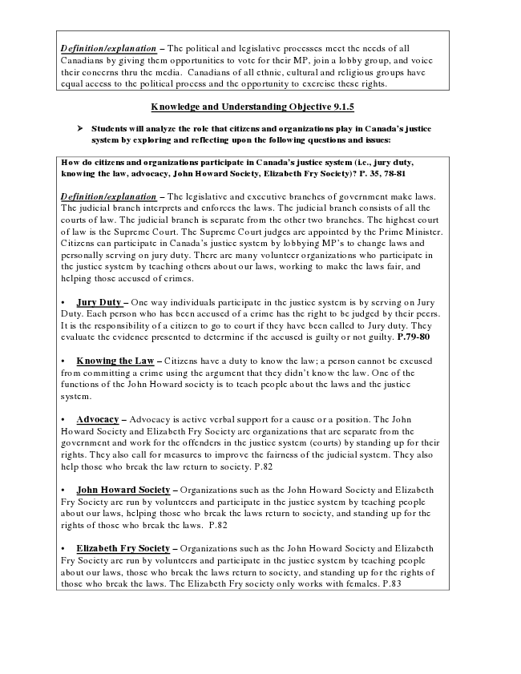
Definition/explanation – The political and legislative processes meet the needs of all Canadians by giving them opportunities to vote for their MP, join a lobby group, and voice their concerns thru the media. Canadians of all ethnic, cultural and religious groups have equal access to the political process and the opportunity to exercise these rights.
Knowledge and Understanding Objective 9.1.5
➢ Students will analyze the role that citizens and organizations play in Canada’s justice
system by exploring and reflecting upon the following questions and issues:
How do citizens and organizations participate in Canada’s justice system (i.e., jury duty, knowing the law, advocacy, John Howard Society, Elizabeth Fry Society)? P. 35, 78-81
Definition/explanation – The legislative and executive branches of government make laws. The judicial branch interprets and enforces the laws. The judicial branch consists of all the courts of law. The judicial branch is separate from the other two branches. The highest court of law is the Supreme Court. The Supreme Court judges are appointed by the Prime Minister. Citizens can participate in Canada’s justice system by lobbying MP’s to change laws and personally serving on jury duty. There are many volunteer organizations who participate in the justice system by teaching others about our laws, working to make the laws fair, and helping those accused of crimes.
• Jury Duty – One way individuals participate in the justice system is by serving on Jury Duty. Each person who has been accused of a crime has the right to be judged by their peers. It is the responsibility of a citizen to go to court if they have been called to Jury duty. They evaluate the evidence presented to determine if the accused is guilty or not guilty. P.79-80
• Knowing the Law – Citizens have a duty to know the law; a person cannot be excused from committing a crime using the argument that they didn’t know the law. One of the functions of the John Howard society is to teach people about the laws and the justice system.
• Advocacy – Advocacy is active verbal support for a cause or a position. The John Howard Society and Elizabeth Fry Society are organizations that are separate from the government and work for the offenders in the justice system (courts) by standing up for their rights. They also call for measures to improve the fairness of the judicial system. They also help those who break the law return to society. P.82
• John Howard Society – Organizations such as the John Howard Society and Elizabeth Fry Society are run by volunteers and participate in the justice system by teaching people about our laws, helping those who break the laws return to society, and standing up for the rights of those who break the laws. P.82
• Elizabeth Fry Society – Organizations such as the John Howard Society and Elizabeth Fry Society are run by volunteers and participate in the justice system by teaching people about our laws, those who break the laws return to society, and standing up for the rights of those who break the laws. The Elizabeth Fry society only works with females. P.83

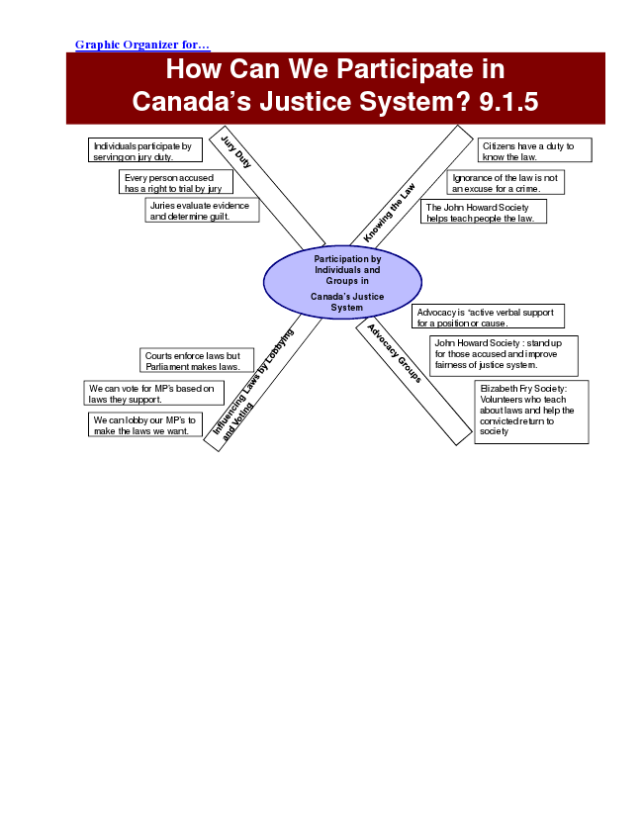
Graphic Organizer for...
How Can We Participate in Canada’s Justice System? 9.1.5
Individuals participate by serving on jury duty.
Every person accused has a right to trial by jury
Participation by Individuals and Groups in
Canada’s Justice System
We can lobby our MP’s to make the laws we want.
Citizens have a duty to know the law.
Ignorance of the law is not an excuse for a crime.
Juries evaluate evidence
The John Howard Society and determine guilt.
helps teach people the law.
Advocacy is “active verbal support for a position or cause.
John Howard Society : stand up Courts enforce laws but
for those accused and improve Parliament makes laws.
fairness of justice system.
We can vote for MP’s based on
Elizabeth Fry Society: laws they support.
Volunteers who teach about laws and help the convicted return to society

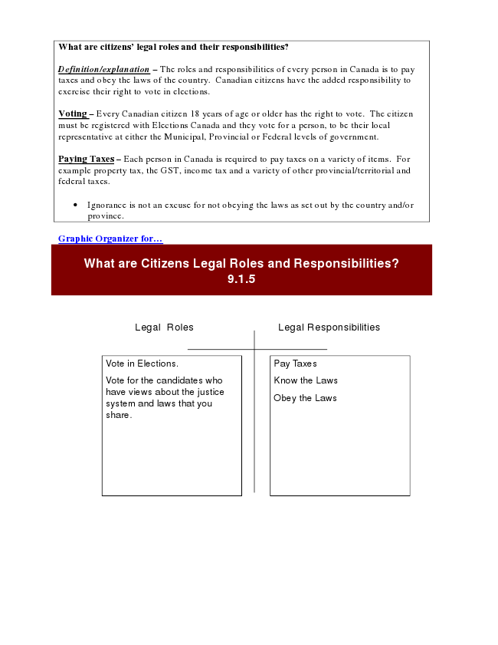
What are citizens’ legal roles and their responsibilities?
Definition/explanation – The roles and responsibilities of every person in Canada is to pay taxes and obey the laws of the country. Canadian citizens have the added responsibility to exercise their right to vote in elections.
Voting – Every Canadian citizen 18 years of age or older has the right to vote. The citizen must be registered with Elections Canada and they vote for a person, to be their local representative at either the Municipal, Provincial or Federal levels of government.
Paying Taxes – Each person in Canada is required to pay taxes on a variety of items. For example property tax, the GST, income tax and a variety of other provincial/territorial and federal taxes.
• Ignorance is not an excuse for not obeying the laws as set out by the country and/or province.
Graphic Organizer for...
What are Citizens Legal Roles and Responsibilities? 9.1.5
Legal Roles Legal Responsibilities
Vote in Elections.
Pay Taxes
Vote for the candidates who
Know the Laws have views about the justice system and laws that you
Obey the Laws
share.

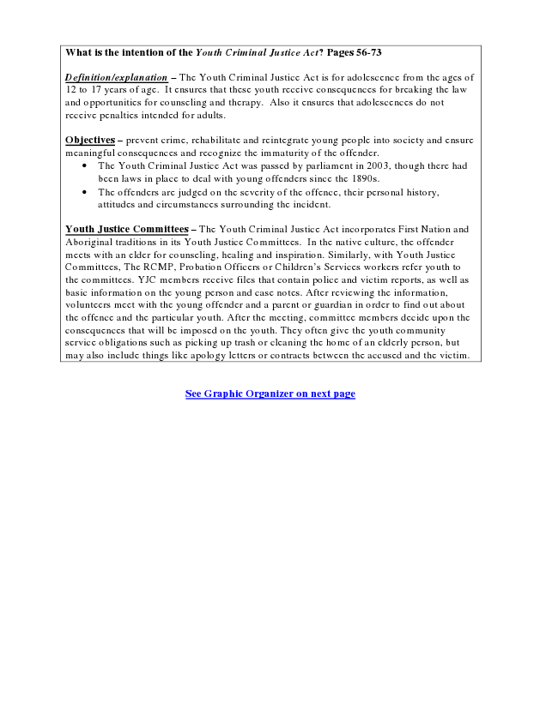
What is the intention of the Youth Criminal Justice Act? Pages 56-73
Definition/explanation – The Youth Criminal Justice Act is for adolescence from the ages of 12 to 17 years of age. It ensures that these youth receive consequences for breaking the law and opportunities for counseling and therapy. Also it ensures that adolescences do not receive penalties intended for adults.
Objectives – prevent crime, rehabilitate and reintegrate young people into society and ensure meaningful consequences and recognize the immaturity of the offender.
• The Youth Criminal Justice Act was passed by parliament in 2003, though there had been laws in place to deal with young offenders since the 1890s.
• The offenders are judged on the severity of the offence, their personal history, attitudes and circumstances surrounding the incident.
Youth Justice Committees – The Youth Criminal Justice Act incorporates First Nation and Aboriginal traditions in its Youth Justice Committees. In the native culture, the offender meets with an elder for counseling, healing and inspiration. Similarly, with Youth Justice Committees, The RCMP, Probation Officers or Children’s Services workers refer youth to the committees. YJC members receive files that contain police and victim reports, as well as basic information on the young person and case notes. After reviewing the information, volunteers meet with the young offender and a parent or guardian in order to find out about the offence and the particular youth. After the meeting, committee members decide upon the consequences that will be imposed on the youth. They often give the youth community service obligations such as picking up trash or cleaning the home of an elderly person, but may also include things like apology letters or contracts between the accused and the victim.
See Graphic Organizer on next page

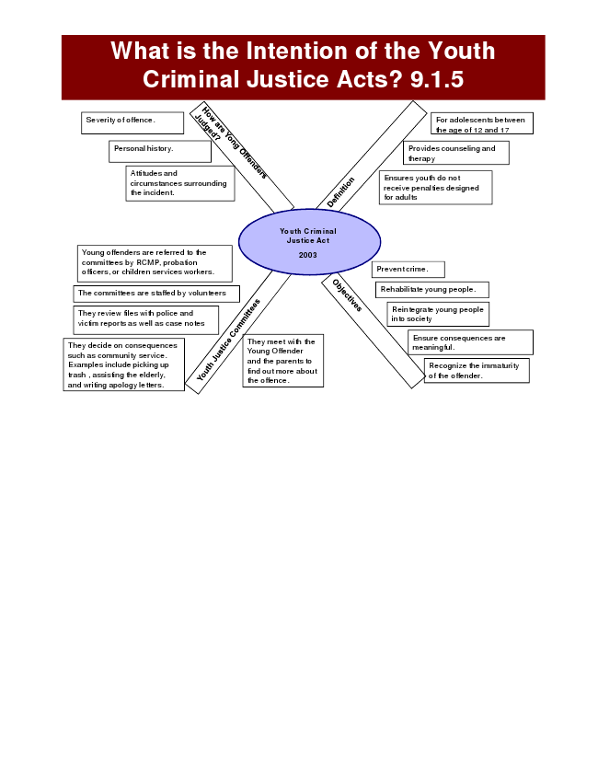
What is the Intention of the Youth Criminal Justice Acts? 9.1.5
Youth Criminal Justice Act
2003
For adolescents between the age of 12 and 17
Provides counseling and therapy
Ensures youth do not receive penalties designed for adults
Prevent crime.
Rehabilitate young people.
They review files with police and victim reports as well as case notes
Reintegrate young people into society
They meet with the Young Offender Severity of offence.
Personal history.
Attitudes and circumstances surrounding the incident.
Young offenders are referred to the committees by RCMP, probation officers, or children services workers.
The committees are staffed by volunteers
Ensure consequences are They decide on consequences
meaningful. such as community service. Examples include picking up trash , assisting the elderly, and writing apology letters.
and the parents to find out more about the offence.
Recognize the immaturity of the offender.

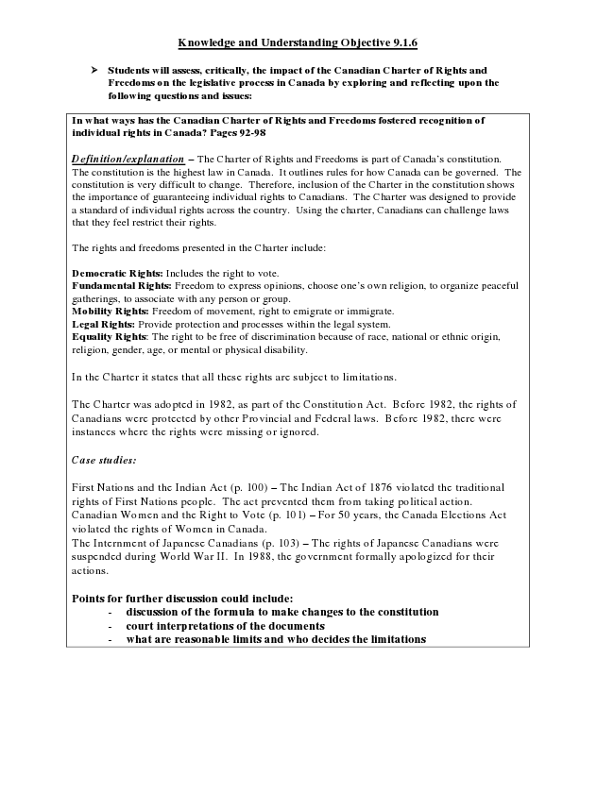
Knowledge and Understanding Objective 9.1.6
➢ Students will assess, critically, the impact of the Canadian Charter of Rights and
Freedoms on the legislative process in Canada by exploring and reflecting upon the following questions and issues:
In what ways has the Canadian Charter of Rights and Freedoms fostered recognition of individual rights in Canada? Pages 92-98
Definition/explanation – The Charter of Rights and Freedoms is part of Canada’s constitution. The constitution is the highest law in Canada. It outlines rules for how Canada can be governed. The constitution is very difficult to change. Therefore, inclusion of the Charter in the constitution shows the importance of guaranteeing individual rights to Canadians. The Charter was designed to provide a standard of individual rights across the country. Using the charter, Canadians can challenge laws that they feel restrict their rights.
The rights and freedoms presented in the Charter include:
Democratic Rights: Includes the right to vote. Fundamental Rights: Freedom to express opinions, choose one’s own religion, to organize peaceful gatherings, to associate with any person or group. Mobility Rights: Freedom of movement, right to emigrate or immigrate. Legal Rights: Provide protection and processes within the legal system. Equality Rights: The right to be free of discrimination because of race, national or ethnic origin, religion, gender, age, or mental or physical disability.
In the Charter it states that all these rights are subject to limitations.
The Charter was adopted in 1982, as part of the Constitution Act. Before 1982, the rights of Canadians were protected by other Provincial and Federal laws. Before 1982, there were instances where the rights were missing or ignored.
Case studies:
First Nations and the Indian Act (p. 100) – The Indian Act of 1876 violated the traditional rights of First Nations people. The act prevented them from taking political action. Canadian Women and the Right to Vote (p. 101) – For 50 years, the Canada Elections Act violated the rights of Women in Canada. The Internment of Japanese Canadians (p. 103) – The rights of Japanese Canadians were suspended during World War II. In 1988, the government formally apologized for their actions.
Points for further discussion could include:
- discussion of the formula to make changes to the constitution - court interpretations of the documents - what are reasonable limits and who decides the limitations

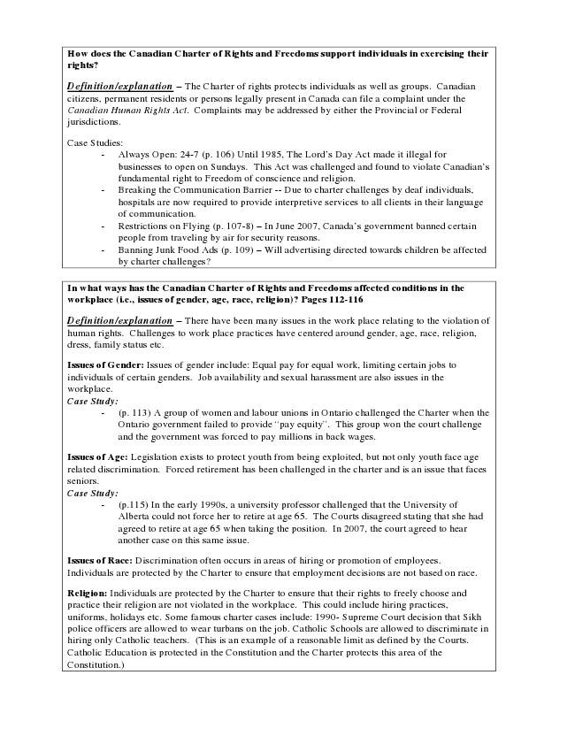
How does the Canadian Charter of Rights and Freedoms support individuals in exercising their rights?
Definition/explanation – The Charter of rights protects individuals as well as groups. Canadian citizens, permanent residents or persons legally present in Canada can file a complaint under the Canadian Human Rights Act. Complaints may be addressed by either the Provincial or Federal jurisdictions.
Case Studies:
- Always Open: 24-7 (p. 106) Until 1985, The Lord’s Day Act made it illegal for
businesses to open on Sundays. This Act was challenged and found to violate Canadian’s fundamental right to Freedom of conscience and religion. - Breaking the Communication Barrier -- Due to charter challenges by deaf individuals,
hospitals are now required to provide interpretive services to all clients in their language of communication. - Restrictions on Flying (p. 107-8) – In June 2007, Canada’s government banned certain
people from traveling by air for security reasons. - Banning Junk Food Ads (p. 109) – Will advertising directed towards children be affected
by charter challenges?
In what ways has the Canadian Charter of Rights and Freedoms affected conditions in the workplace (i.e., issues of gender, age, race, religion)? Pages 112-116
Definition/explanation – There have been many issues in the work place relating to the violation of human rights. Challenges to work place practices have centered around gender, age, race, religion, dress, family status etc.
Issues of Gender: Issues of gender include: Equal pay for equal work, limiting certain jobs to individuals of certain genders. Job availability and sexual harassment are also issues in the workplace. Case Study:
- (p. 113) A group of women and labour unions in Ontario challenged the Charter when the
Ontario government failed to provide “pay equity”. This group won the court challenge and the government was forced to pay millions in back wages.
Issues of Age: Legislation exists to protect youth from being exploited, but not only youth face age related discrimination. Forced retirement has been challenged in the charter and is an issue that faces seniors. Case Study:
- (p.115) In the early 1990s, a university professor challenged that the University of
Alberta could not force her to retire at age 65. The Courts disagreed stating that she had agreed to retire at age 65 when taking the position. In 2007, the court agreed to hear another case on this same issue.
Issues of Race: Discrimination often occurs in areas of hiring or promotion of employees. Individuals are protected by the Charter to ensure that employment decisions are not based on race.
Religion: Individuals are protected by the Charter to ensure that their rights to freely choose and practice their religion are not violated in the workplace. This could include hiring practices, uniforms, holidays etc. Some famous charter cases include: 1990- Supreme Court decision that Sikh police officers are allowed to wear turbans on the job. Catholic Schools are allowed to discriminate in hiring only Catholic teachers. (This is an example of a reasonable limit as defined by the Courts. Catholic Education is protected in the Constitution and the Charter protects this area of the Constitution.)

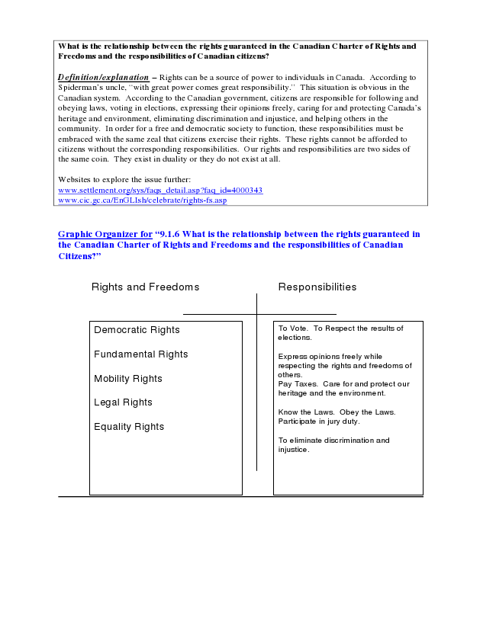
What is the relationship between the rights guaranteed in the Canadian Charter of Rights and Freedoms and the responsibilities of Canadian citizens?
Definition/explanation – Rights can be a source of power to individuals in Canada. According to Spiderman’s uncle, “with great power comes great responsibility.” This situation is obvious in the Canadian system. According to the Canadian government, citizens are responsible for following and obeying laws, voting in elections, expressing their opinions freely, caring for and protecting Canada’s heritage and environment, eliminating discrimination and injustice, and helping others in the community. In order for a free and democratic society to function, these responsibilities must be embraced with the same zeal that citizens exercise their rights. These rights cannot be afforded to citizens without the corresponding responsibilities. Our rights and responsibilities are two sides of the same coin. They exist in duality or they do not exist at all.
Websites to explore the issue further: www.settlement.org/sys/faqs_detail.asp?faq_id=4000343 www.cic.gc.ca/EnGLIsh/celebrate/rights-fs.asp
Graphic Organizer for “9.1.6 What is the relationship between the rights guaranteed in the Canadian Charter of Rights and Freedoms and the responsibilities of Canadian Citizens?”
Rights and Freedoms Responsibilities
Democratic Rights
To Vote. To Respect the results of elections. Fundamental Rights
Express opinions freely while respecting the rights and freedoms of Mobility Rights
others. Pay Taxes. Care for and protect our
Legal Rights
heritage and the environment.
Know the Laws. Obey the Laws. Equality Rights
Participate in jury duty.
To eliminate discrimination and injustice.

