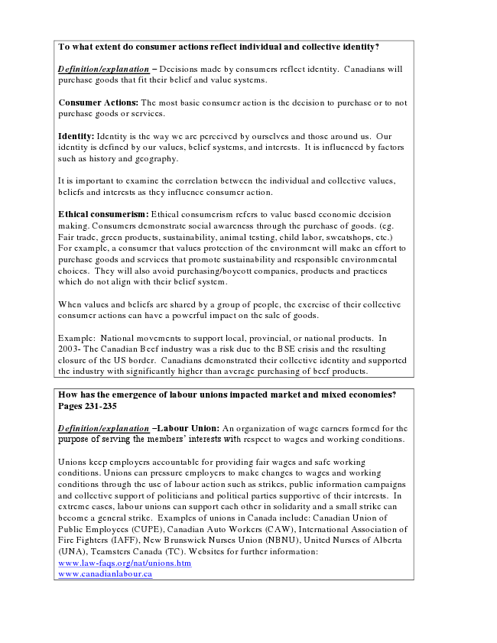
To what extent do consumer actions reflect individual and collective identity?
Definition/explanation – Decisions made by consumers reflect identity. Canadians will purchase goods that fit their belief and value systems.
Consumer Actions: The most basic consumer action is the decision to purchase or to not purchase goods or services.
Identity: Identity is the way we are perceived by ourselves and those around us. Our identity is defined by our values, belief systems, and interests. It is influenced by factors such as history and geography.
It is important to examine the correlation between the individual and collective values, beliefs and interests as they influence consumer action.
Ethical consumerism: Ethical consumerism refers to value based economic decision making. Consumers demonstrate social awareness through the purchase of goods. (eg. Fair trade, green products, sustainability, animal testing, child labor, sweatshops, etc.) For example, a consumer that values protection of the environment will make an effort to purchase goods and services that promote sustainability and responsible environmental choices. They will also avoid purchasing/boycott companies, products and practices which do not align with their belief system.
When values and beliefs are shared by a group of people, the exercise of their collective consumer actions can have a powerful impact on the sale of goods.
Example: National movements to support local, provincial, or national products. In 2003- The Canadian Beef industry was a risk due to the BSE crisis and the resulting closure of the US border. Canadians demonstrated their collective identity and supported the industry with significantly higher than average purchasing of beef products.
How has the emergence of labour unions impacted market and mixed economies? Pages 231-235
Definition/explanation –Labour Union: An organization of wage earners formed for the purpose of serving the members’ interests with respect to wages and working conditions.
Unions keep employers accountable for providing fair wages and safe working conditions. Unions can pressure employers to make changes to wages and working conditions through the use of labour action such as strikes, public information campaigns and collective support of politicians and political parties supportive of their interests. In extreme cases, labour unions can support each other in solidarity and a small strike can become a general strike. Examples of unions in Canada include: Canadian Union of Public Employees (CUPE), Canadian Auto Workers (CAW), International Association of Fire Fighters (IAFF), New Brunswick Nurses Union (NBNU), United Nurses of Alberta (UNA), Teamsters Canada (TC). Websites for further information: www.law-faqs.org/nat/unions.htm www.canadianlabour.ca

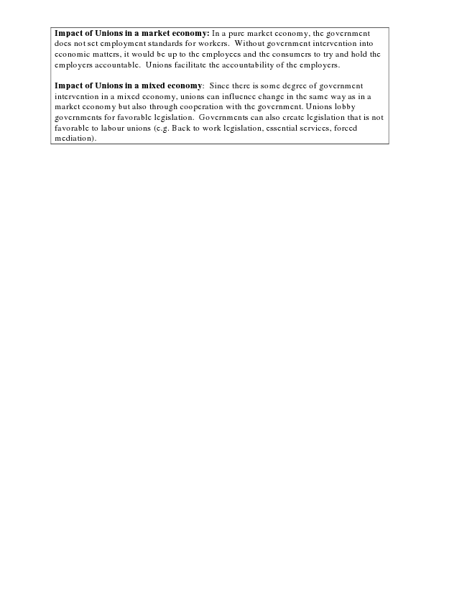
Impact of Unions in a market economy: In a pure market economy, the government does not set employment standards for workers. Without government intervention into economic matters, it would be up to the employees and the consumers to try and hold the employers accountable. Unions facilitate the accountability of the employers.
Impact of Unions in a mixed economy: Since there is some degree of government intervention in a mixed economy, unions can influence change in the same way as in a market economy but also through cooperation with the government. Unions lobby governments for favorable legislation. Governments can also create legislation that is not favorable to labour unions (e.g. Back to work legislation, essential services, forced mediation).

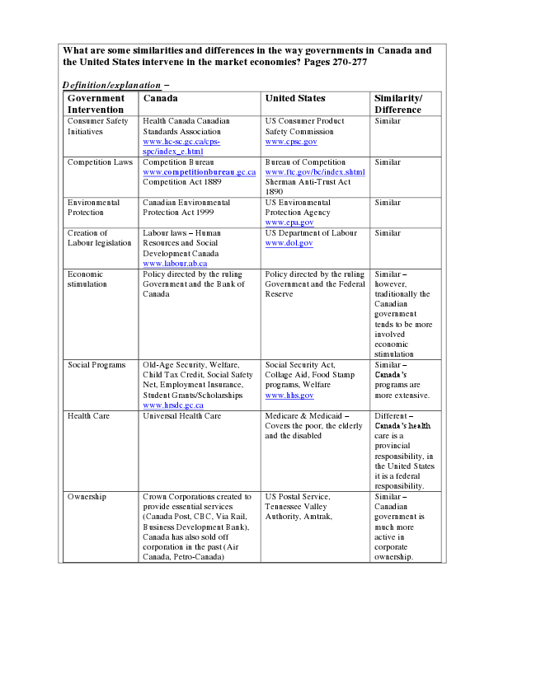
What are some similarities and differences in the way governments in Canada and the United States intervene in the market economies? Pages 270-277
Definition/explanation –
Government Intervention
Canada United States Similarity/ Difference Consumer Safety Initiatives
Health Canada Canadian Standards Association www.hc-sc.gc.ca/cps- spc/index_e.html
US Consumer Product Safety Commission www.cpsc.gov
Similar
Competition Laws Competition Bureau
www.competitionbureau.gc.ca Competition Act 1889
Bureau of Competition www.ftc.gov/bc/index.shtml Sherman Anti-Trust Act 1890
Similar
Environmental Protection
Canadian Environmental Protection Act 1999
US Environmental Protection Agency www.epa.gov
Similar
Creation of Labour legislation
Labour laws – Human Resources and Social Development Canada www.labour.ab.ca
US Department of Labour www.dol.gov
Similar
Economic stimulation
Policy directed by the ruling Government and the Bank of Canada
Policy directed by the ruling Government and the Federal Reserve
Similar – however, traditionally the Canadian government tends to be more involved economic stimulation Social Programs Old-Age Security, Welfare,
Child Tax Credit, Social Safety Net, Employment Insurance, Student Grants/Scholarships www.hrsdc.gc.ca
Social Security Act, Collage Aid, Food Stamp programs, Welfare www.hhs.gov
Similar – Canada’s programs are more extensive.
Health Care Universal Health Care Medicare & Medicaid –
Covers the poor, the elderly and the disabled
Different – Canada’s health care is a provincial responsibility, in the United States it is a federal responsibility. Ownership Crown Corporations created to
provide essential services (Canada Post, CBC, Via Rail, Business Development Bank), Canada has also sold off corporation in the past (Air Canada, Petro-Canada)
US Postal Service, Tennessee Valley Authority, Amtrak,
Similar – Canadian government is much more active in corporate ownership.

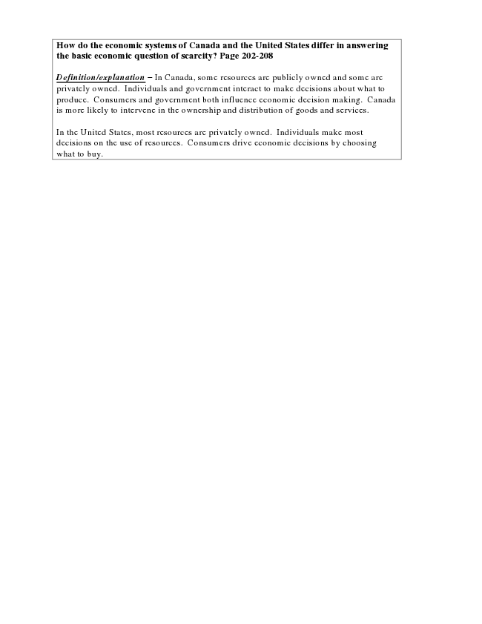
How do the economic systems of Canada and the United States differ in answering the basic economic question of scarcity? Page 202-208
Definition/explanation – In Canada, some resources are publicly owned and some are privately owned. Individuals and government interact to make decisions about what to produce. Consumers and government both influence economic decision making. Canada is more likely to intervene in the ownership and distribution of goods and services.
In the United States, most resources are privately owned. Individuals make most decisions on the use of resources. Consumers drive economic decisions by choosing what to buy.

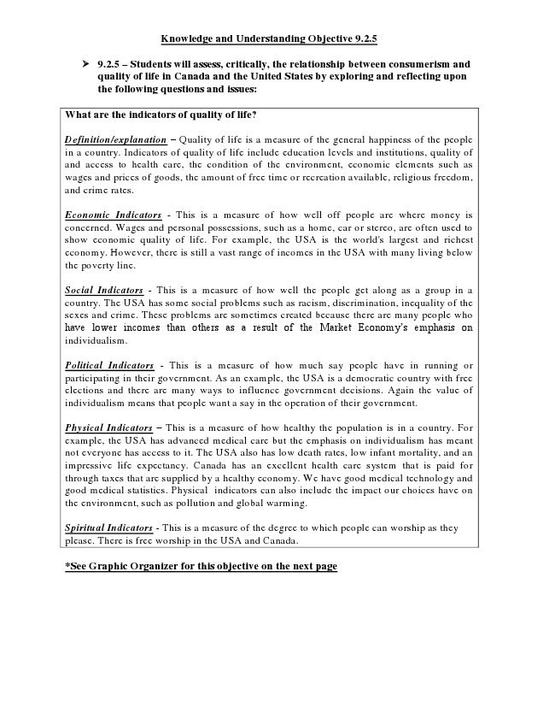
Knowledge and Understanding Objective 9.2.5
➢ 9.2.5 – Students will assess, critically, the relationship between consumerism and
quality of life in Canada and the United States by exploring and reflecting upon the following questions and issues:
What are the indicators of quality of life?
Definition/explanation – Quality of life is a measure of the general happiness of the people in a country. Indicators of quality of life include education levels and institutions, quality of and access to health care, the condition of the environment, economic elements such as wages and prices of goods, the amount of free time or recreation available, religious freedom, and crime rates.
Economic Indicators - This is a measure of how well off people are where money is concerned. Wages and personal possessions, such as a home, car or stereo, are often used to show economic quality of life. For example, the USA is the world's largest and richest economy. However, there is still a vast range of incomes in the USA with many living below the poverty line.
Social Indicators - This is a measure of how well the people get along as a group in a country. The USA has some social problems such as racism, discrimination, inequality of the sexes and crime. These problems are sometimes created because there are many people who have lower incomes than others as a result of the Market Economy’s emphasis on individualism.
Political Indicators - This is a measure of how much say people have in running or participating in their government. As an example, the USA is a democratic country with free elections and there are many ways to influence government decisions. Again the value of individualism means that people want a say in the operation of their government.
Physical Indicators – This is a measure of how healthy the population is in a country. For example, the USA has advanced medical care but the emphasis on individualism has meant not everyone has access to it. The USA also has low death rates, low infant mortality, and an impressive life expectancy. Canada has an excellent health care system that is paid for through taxes that are supplied by a healthy economy. We have good medical technology and good medical statistics. Physical indicators can also include the impact our choices have on the environment, such as pollution and global warming.
Spiritual Indicators - This is a measure of the degree to which people can worship as they please. There is free worship in the USA and Canada.
*See Graphic Organizer for this objective on the next page

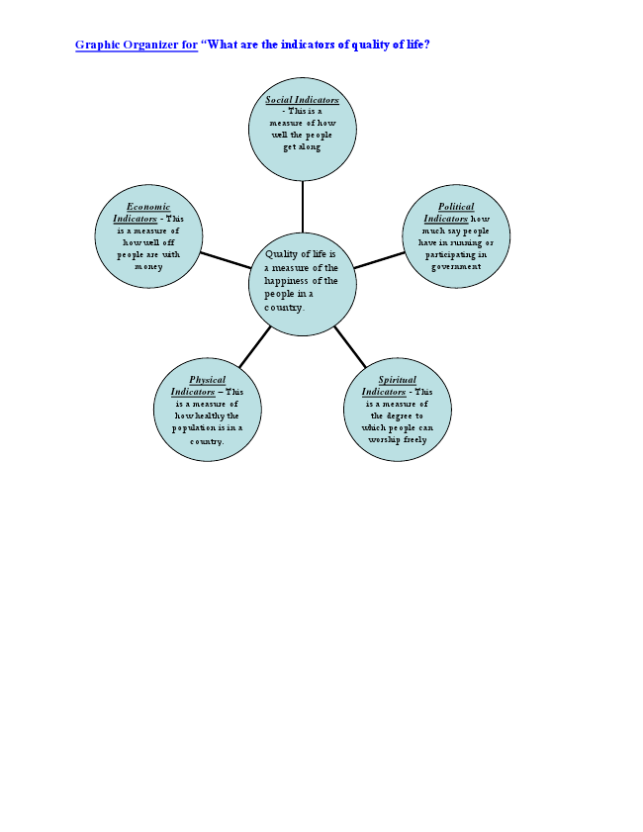
Graphic Organizer for “What are the indicators of quality of life?
Economic Indicators - This is a measure of how well off people are with money
Physical Indicators – This is a measure of how healthy the population is in a country.
Social Indicators - This is a measure of how well the people get along
Quality of life is a measure of the happiness of the people in a country.
Political Indicators how much say people have in running or participating in government
Spiritual Indicators - This is a measure of the degree to which people can worship freely please.

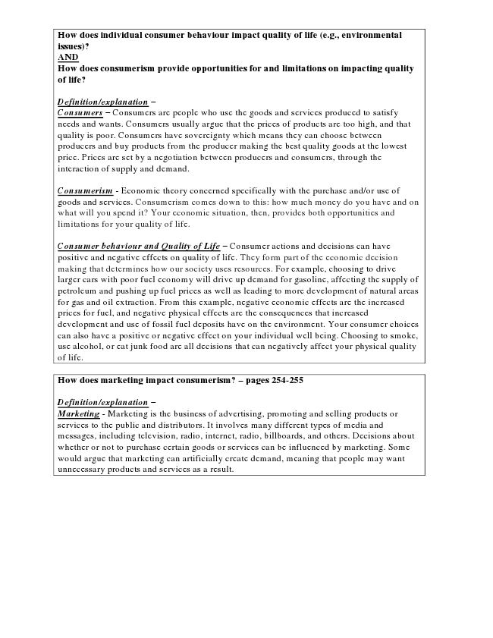
How does individual consumer behaviour impact quality of life (e.g., environmental issues)? AND How does consumerism provide opportunities for and limitations on impacting quality of life?
Definition/explanation – Consumers – Consumers are people who use the goods and services produced to satisfy needs and wants. Consumers usually argue that the prices of products are too high, and that quality is poor. Consumers have sovereignty which means they can choose between producers and buy products from the producer making the best quality goods at the lowest price. Prices are set by a negotiation between producers and consumers, through the interaction of supply and demand.
Consumerism - Economic theory concerned specifically with the purchase and/or use of goods and services. Consumerism comes down to this: how much money do you have and on what will you spend it? Your economic situation, then, provides both opportunities and limitations for your quality of life.
Consumer behaviour and Quality of Life – Consumer actions and decisions can have positive and negative effects on quality of life. They form part of the economic decision making that determines how our society uses resources. For example, choosing to drive larger cars with poor fuel economy will drive up demand for gasoline, affecting the supply of petroleum and pushing up fuel prices as well as leading to more development of natural areas for gas and oil extraction. From this example, negative economic effects are the increased prices for fuel, and negative physical effects are the consequences that increased development and use of fossil fuel deposits have on the environment. Your consumer choices can also have a positive or negative effect on your individual well being. Choosing to smoke, use alcohol, or eat junk food are all decisions that can negatively affect your physical quality of life.
How does marketing impact consumerism? – pages 254-255
Definition/explanation – Marketing - Marketing is the business of advertising, promoting and selling products or services to the public and distributors. It involves many different types of media and messages, including television, radio, internet, radio, billboards, and others. Decisions about whether or not to purchase certain goods or services can be influenced by marketing. Some would argue that marketing can artificially create demand, meaning that people may want unnecessary products and services as a result.

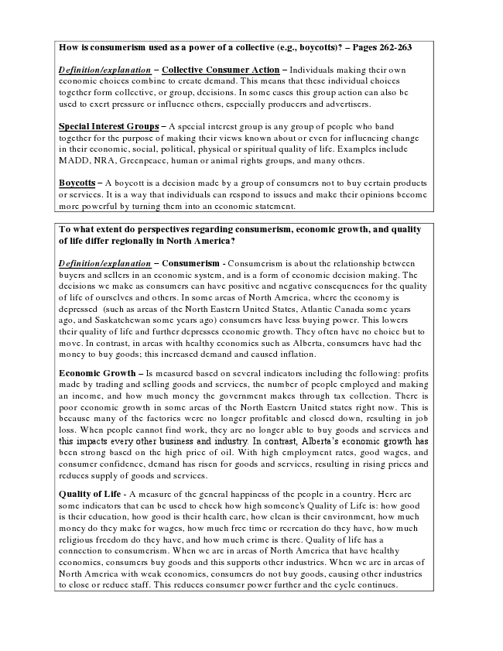
How is consumerism used as a power of a collective (e.g., boycotts)? – Pages 262-263
Definition/explanation – Collective Consumer Action – Individuals making their own economic choices combine to create demand. This means that these individual choices together form collective, or group, decisions. In some cases this group action can also be used to exert pressure or influence others, especially producers and advertisers.
Special Interest Groups – A special interest group is any group of people who band together for the purpose of making their views known about or even for influencing change in their economic, social, political, physical or spiritual quality of life. Examples include MADD, NRA, Greenpeace, human or animal rights groups, and many others.
Boycotts – A boycott is a decision made by a group of consumers not to buy certain products or services. It is a way that individuals can respond to issues and make their opinions become more powerful by turning them into an economic statement.
To what extent do perspectives regarding consumerism, economic growth, and quality of life differ regionally in North America?
Definition/explanation – Consumerism - Consumerism is about the relationship between buyers and sellers in an economic system, and is a form of economic decision making. The decisions we make as consumers can have positive and negative consequences for the quality of life of ourselves and others. In some areas of North America, where the economy is depressed (such as areas of the North Eastern United States, Atlantic Canada some years ago, and Saskatchewan some years ago) consumers have less buying power. This lowers their quality of life and further depresses economic growth. They often have no choice but to move. In contrast, in areas with healthy economies such as Alberta, consumers have had the money to buy goods; this increased demand and caused inflation.
Economic Growth – Is measured based on several indicators including the following: profits made by trading and selling goods and services, the number of people employed and making an income, and how much money the government makes through tax collection. There is poor economic growth in some areas of the North Eastern United states right now. This is because many of the factories were no longer profitable and closed down, resulting in job loss. When people cannot find work, they are no longer able to buy goods and services and this impacts every other business and industry. In contrast, Alberta’s economic growth has been strong based on the high price of oil. With high employment rates, good wages, and consumer confidence, demand has risen for goods and services, resulting in rising prices and reduces supply of goods and services.
Quality of Life - A measure of the general happiness of the people in a country. Here are some indicators that can be used to check how high someone's Quality of Life is: how good is their education, how good is their health care, how clean is their environment, how much money do they make for wages, how much free time or recreation do they have, how much religious freedom do they have, and how much crime is there. Quality of life has a connection to consumerism. When we are in areas of North America that have healthy economies, consumers buy goods and this supports other industries. When we are in areas of North America with weak economies, consumers do not buy goods, causing other industries to close or reduce staff. This reduces consumer power further and the cycle continues.

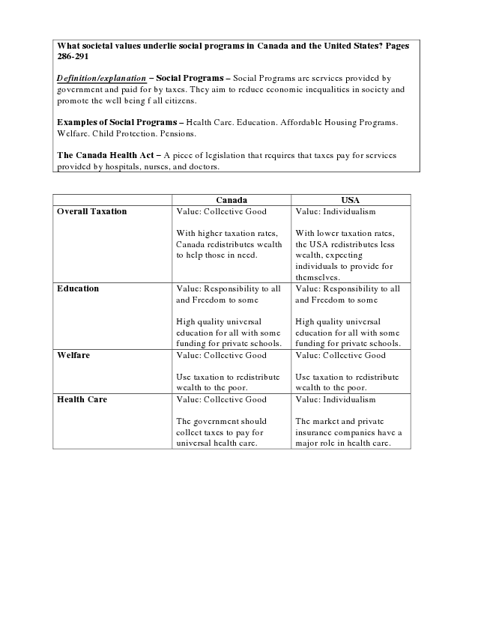
What societal values underlie social programs in Canada and the United States? Pages 286-291
Definition/explanation – Social Programs – Social Programs are services provided by government and paid for by taxes. They aim to reduce economic inequalities in society and promote the well being f all citizens.
Examples of Social Programs – Health Care. Education. Affordable Housing Programs. Welfare. Child Protection. Pensions.
The Canada Health Act – A piece of legislation that requires that taxes pay for services provided by hospitals, nurses, and doctors.
Canada USA Overall Taxation Value: Collective Good
With higher taxation rates, Canada redistributes wealth to help those in need.
Value: Individualism
With lower taxation rates, the USA redistributes less wealth, expecting individuals to provide for themselves. Education Value: Responsibility to all
and Freedom to some
High quality universal education for all with some funding for private schools.
Value: Responsibility to all and Freedom to some
High quality universal education for all with some funding for private schools. Welfare Value: Collective Good
Use taxation to redistribute wealth to the poor.
Value: Collective Good
Use taxation to redistribute wealth to the poor. Health Care Value: Collective Good
The government should collect taxes to pay for universal health care.
Value: Individualism
The market and private insurance companies have a major role in health care.

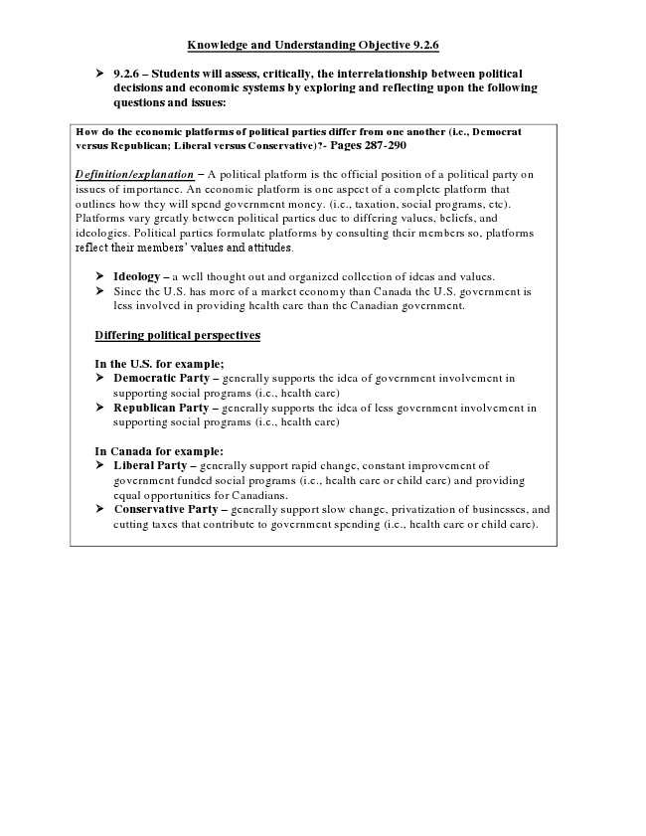
Knowledge and Understanding Objective 9.2.6
➢ 9.2.6 – Students will assess, critically, the interrelationship between political
decisions and economic systems by exploring and reflecting upon the following questions and issues:
How do the economic platforms of political parties differ from one another (i.e., Democrat versus Republican; Liberal versus Conservative)?- Pages 287-290
Definition/explanation – A political platform is the official position of a political party on issues of importance. An economic platform is one aspect of a complete platform that outlines how they will spend government money. (i.e., taxation, social programs, etc). Platforms vary greatly between political parties due to differing values, beliefs, and ideologies. Political parties formulate platforms by consulting their members so, platforms reflect their members’ values and attitudes.
➢ Ideology – a well thought out and organized collection of ideas and values. ➢ Since the U.S. has more of a market economy than Canada the U.S. government is
less involved in providing health care than the Canadian government.
Differing political perspectives
In the U.S. for example; ➢ Democratic Party – generally supports the idea of government involvement in
supporting social programs (i.e., health care) ➢ Republican Party – generally supports the idea of less government involvement in
supporting social programs (i.e., health care)
In Canada for example: ➢ Liberal Party – generally support rapid change, constant improvement of
government funded social programs (i.e., health care or child care) and providing equal opportunities for Canadians. ➢ Conservative Party – generally support slow change, privatization of businesses, and
cutting taxes that contribute to government spending (i.e., health care or child care).

